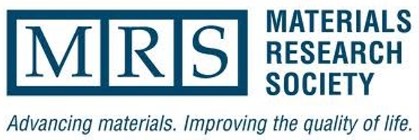
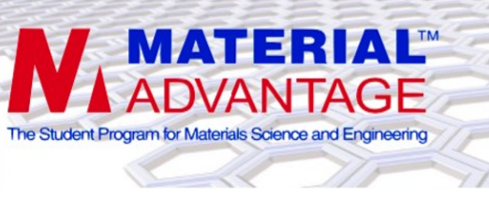
3rd Annual WVU
Mountaineer Maker's Challenge

Sponsored by the WVU Chapters of the
Materials Advantage & Materials Research Society

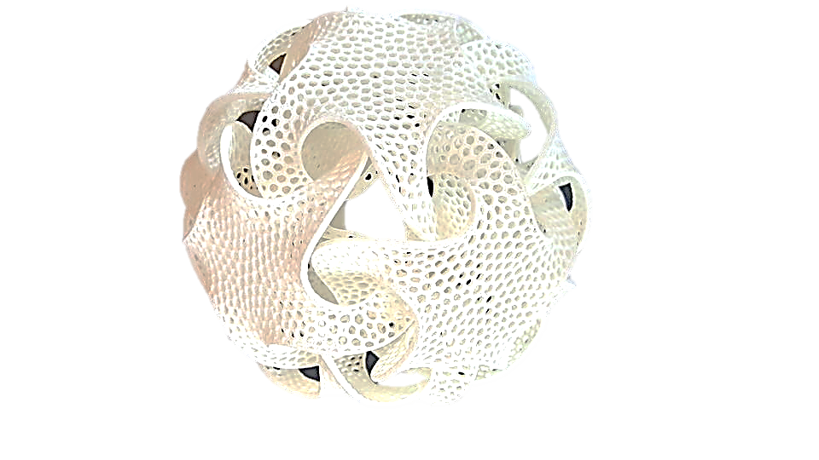
What is the Maker’s Challenge?
A 3D Printing Competition!
To create and 3D print a unique design
Submissions will be judged via open voting and design criteria

What are the Challenge Categories?
- Creative Artistic Design
- Engineering Assembly
- Bridge Design Challenge

How to Register?
See the MA/MRS website:
MaterialAdvantage.orgs.wvu.edu

Here you can download the registration form & read more
about the competition guidelines & rules!
Early Registration: $5 Registration at Event: $8
3D Printing Services available through MA/MRS ($0.20/cm³ printing vol.)

For More Information:
Email your registration with any questions to:
Thank you to our Sponsors:
WVU Statler College of Engineering and Mineral Resources
Department of Mechanical and Aerospace Engineering
Statler College Office of Outreach and Recruitment
wvu.materials@gmail.com

